Now, we have to deploy this Web Scraper which we created in the last lab. Hence, we will first use Flask.

Download the github repository so that we get ready-made UI.

Link to repo -> <https://github.com/iNeuronai/new_pw_eng_scrap>

Download this repo and open it with VScode. Clone the repo in the VScode terminal so that the repo is copied onto your local system.

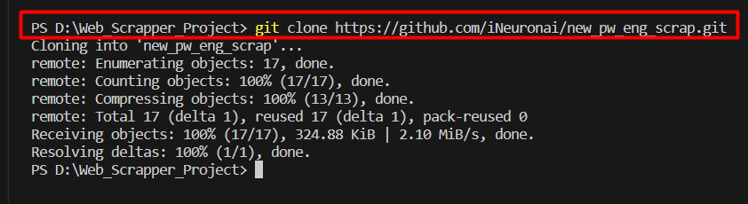

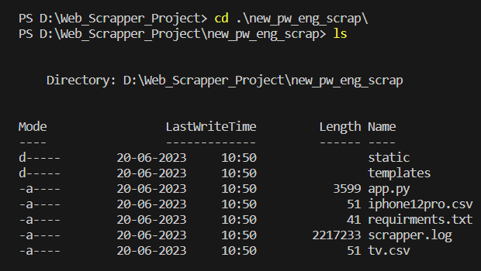

Read the “app.py” file.

flask_cors is used to avoid issues while deployment. Suppose our server is located in India and someone is trying to access the website from the USA then, this creates a conflict.

First, you have to pip install requirements.txt file.

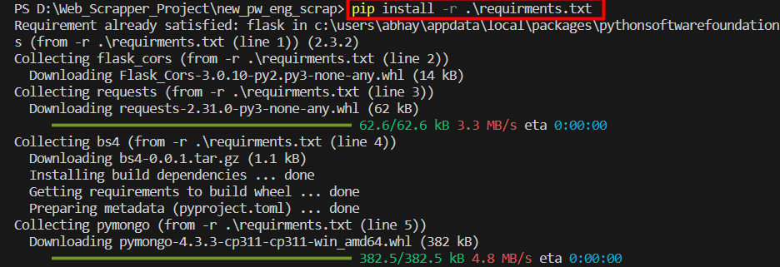

After that run app.py file and browse the local link - <http://127.0.0.1:5000/>

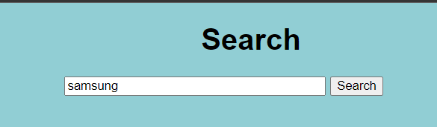

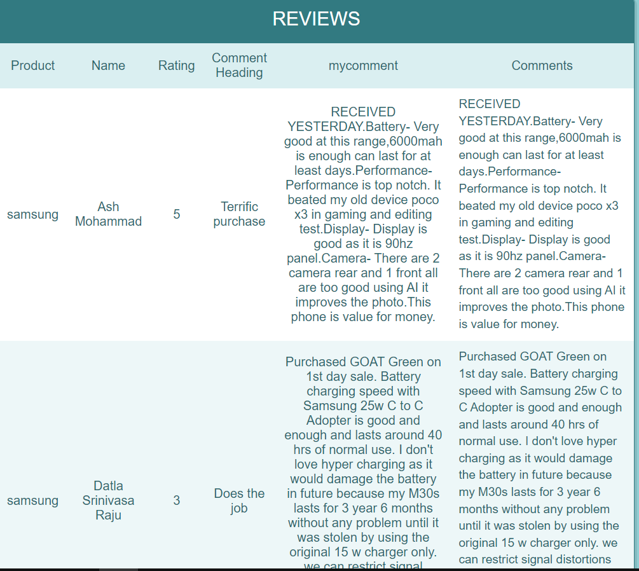

We can also store this data using **MongoDB**.

Sign into your MongoDB account. Using a cluster, click on “connect”.

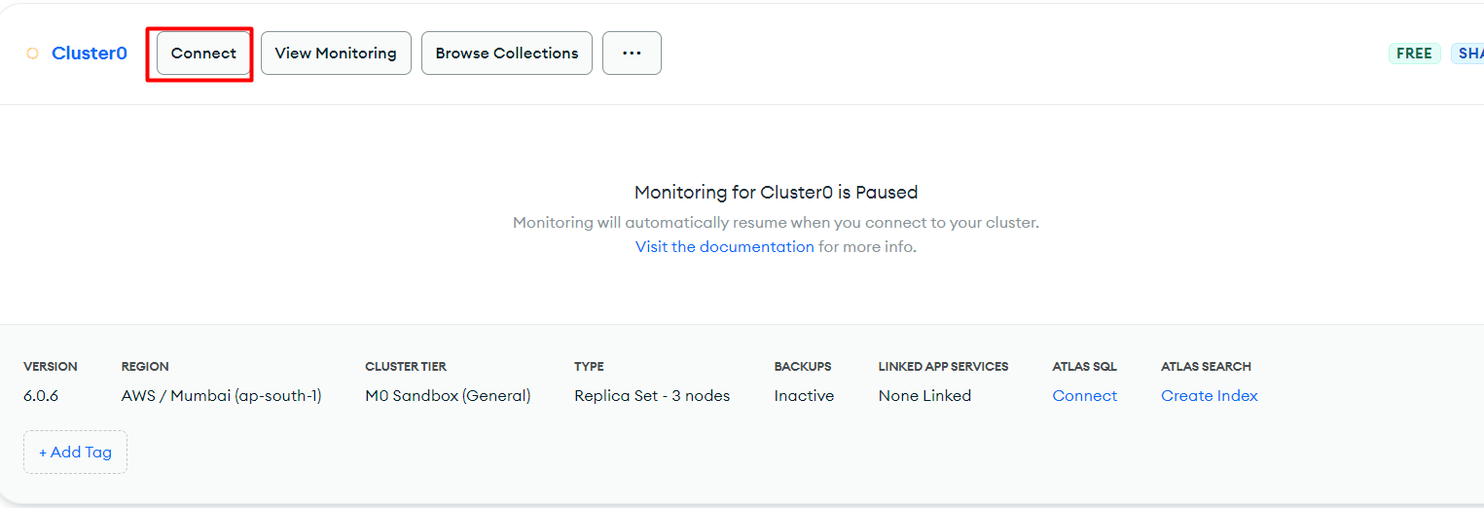Using drivers, select “python” -> version 3.6 or later

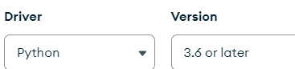

Then type “ python -m pip install pymongo==3.6 ” in your terminal

Then, use the given FULL sample code to connect your python code to database

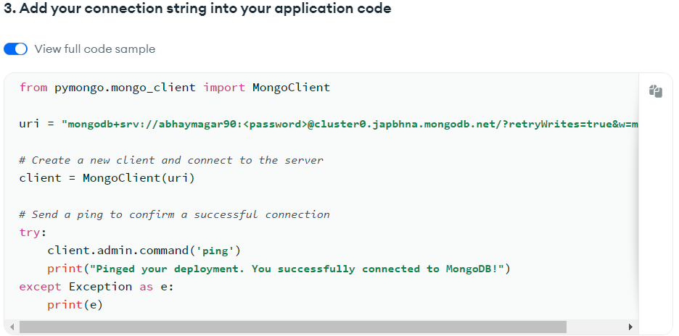

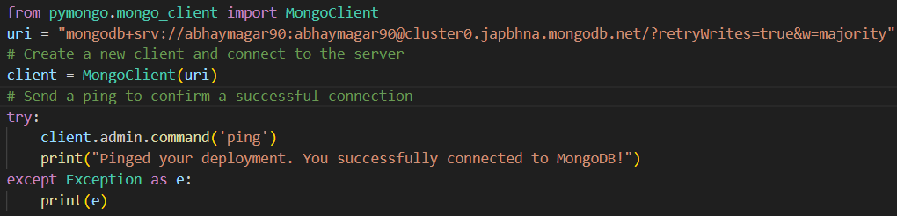

**Note:** Include **username** and **password** properly in the above code

Hence, using client we will create a database ['scrapper_eng_pwskills']

Using this database, we will create collection ['scraper_pwskills_eng']

Then we will use insert_many to insert all the reviews in the collection.

**Example:**

coll_pw_eng.insertMany(reviews)

Internally,

coll_pw_eng.insertMany( [ {doc 1}, {doc2} ……… {doc n} ] ) where each doc is a dictionary

In this way, our search results will be stored in mongodb

Now, we can run python app.py file and search anything in the webpage. We will get the search results on the webpage. The same search results will also be stored in our database in mongodb.

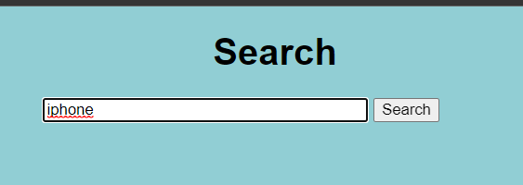

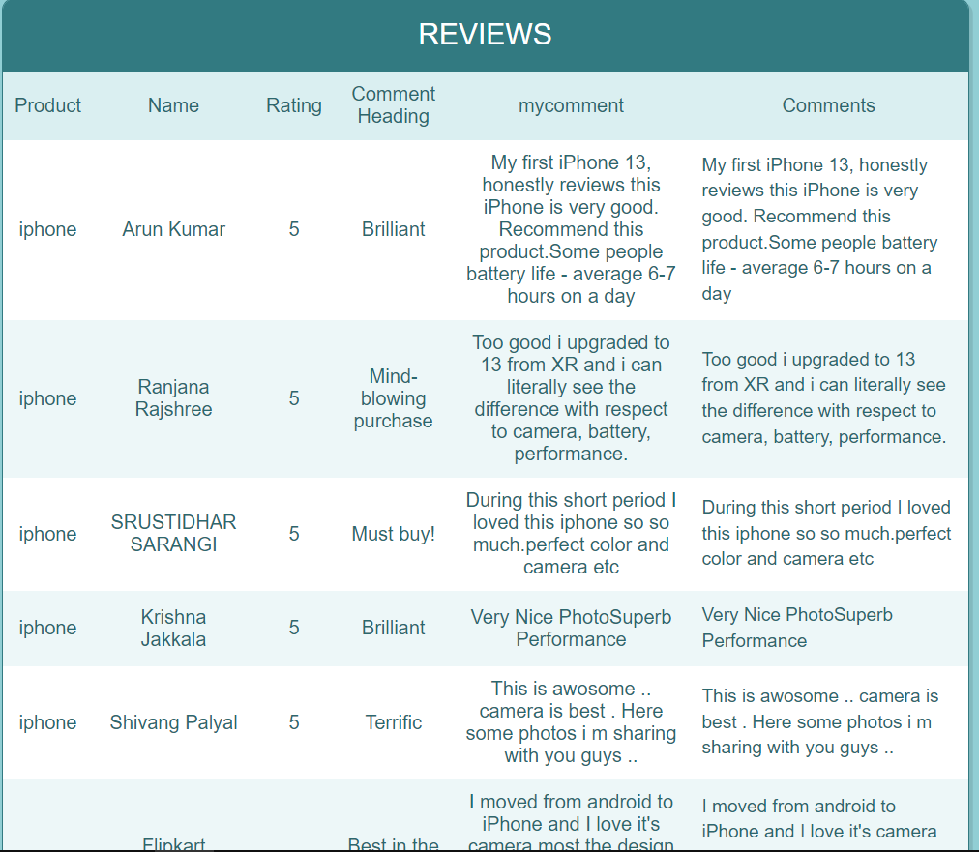

After browsing collections in your cluster0, you can see that the above results are stored in the database.

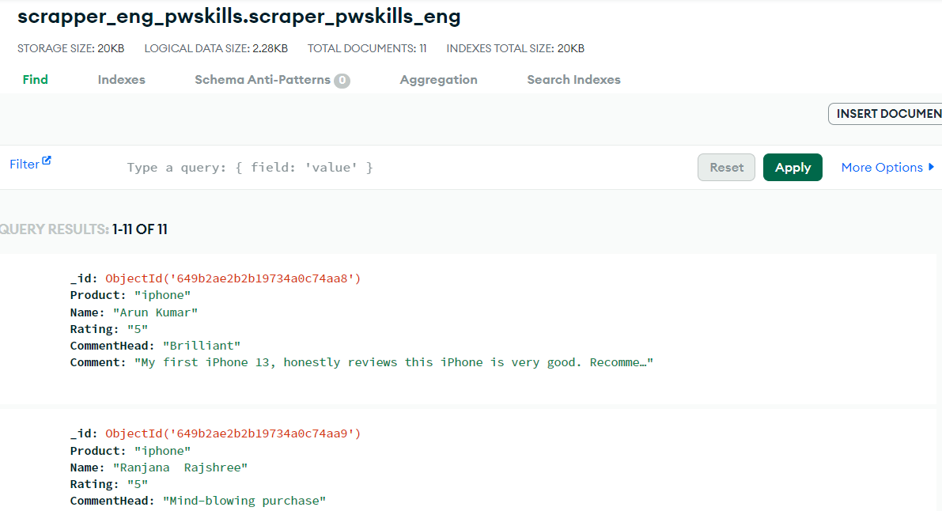

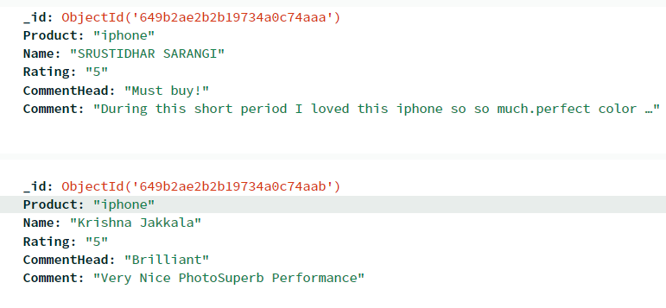

Now, our project is complete.

Now, we will push this code into a github repository.

I created a new repository named 1.WebScrapping_Project. Now, I will push my web scraping project folder into this repo.

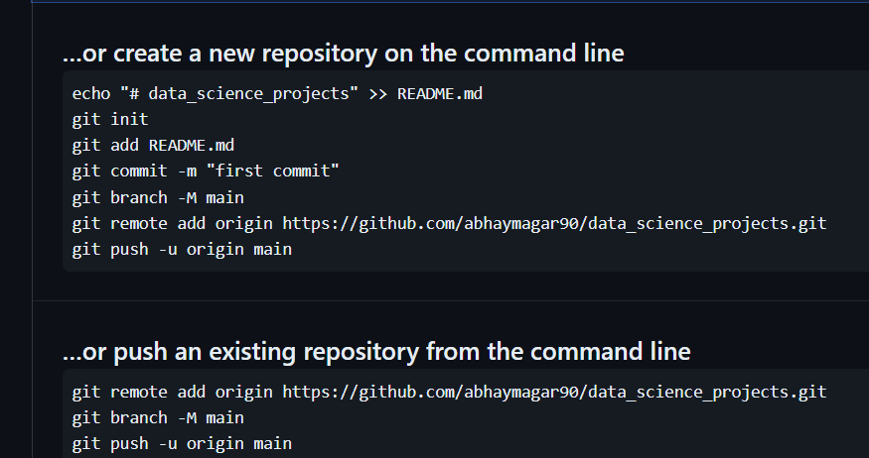

Check the repository. Your files will be added in it.